Branch: MCA (Data Science) Kargil | Semester: 2
Student Name: Kunal Gupta | UID: 25MCD10013
Subject Name: Technical Training - I Lab | Subject Code: 25CAP-652
Section/Group: 25MCD KAR-1 | Date of Performance: 27-02-2026

Experiment 5
- Aim: To gain hands-on experience in creating and using cursors for row-by-row processing in a database, enabling sequential access and manipulation of query results for complex business logic. (Company Tags: Infosys, Wipro, TCS, Capgemini)

- Tools used: PostgreSQL

- Objectives:
- Sequential Data Access: To understand how to fetch rows one by one from a result set using cursor mechanisms.
- Row-Level Manipulation: To perform specific operations or calculations on individual records that require conditional procedural logic.
- Resource Management: To learn the lifecycle of a cursor: Declaring, Opening, Fetching, and importantly, Closing and Deallocating to manage system memory.
- Exception Handling: To handle cursor-related errors and performance considerations during large-scale data iteration.
4. Theory: While SQL is generally set-oriented, certain tasks require a procedural approach where we process one row at a time. This is where Cursors are used:
- Cursor Types: Cursors can be Implicit (managed by the system) or Explicit (defined by the developer). They can also be Forward-Only (moving only toward the end) or Scrollable (moving back and forth).
- The Lifecycle: * DECLARE: Defines the SQL query for the cursor.
  - OPEN: Executes the query and establishes the result set.
  - FETCH: Retrieves a specific row into variables for processing.
  - CLOSE: Releases the current result set.
  - DEALLOCATE: Removes the cursor definition from memory.
- Use Case: Cursors are ideal for generating row-specific reports, updating balances based on complex historical data, or migrating data where each record needs individual validation.

5. Experiment Steps:
Step 1: Implementing a Simple Forward-Only Cursor
Creating a cursor to loop through an Employee table and print individual records.
Query:
-- Query 1
-- Create Staff table
CREATE TABLE IF NOT EXISTS Staff (
StaffID INT PRIMARY KEY,
StaffName VARCHAR(50),
MonthlyPay INT
);
-- Insert sample data
INSERT INTO Staff VALUES (101, 'Dr. Meera', 70000)
ON CONFLICT (StaffID) DO NOTHING;
INSERT INTO Staff VALUES (102, 'Nurse Karan', 45000)
ON CONFLICT (StaffID) DO NOTHING;
INSERT INTO Staff VALUES (103, 'Technician Isha', 38000)
ON CONFLICT (StaffID) DO NOTHING;
-- Cursor block
DO $$
DECLARE
staff_record RECORD;
staff_cursor CURSOR FOR
SELECT StaffID, StaffName, MonthlyPay FROM Staff;
BEGIN
OPEN staff_cursor;
LOOP
FETCH staff_cursor INTO staff_record;
EXIT WHEN NOT FOUND;
RAISE NOTICE 'ID: %, Name: %, Monthly Pay: %',
staff_record.StaffID,
staff_record.StaffName,
staff_record.MonthlyPay;
END LOOP;
CLOSE staff_cursor;
END $$;

Output:
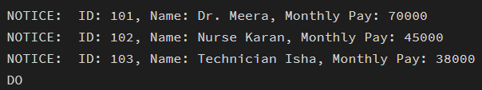

Step 2: Complex Row-by-Row Manipulation
Using a cursor to update salaries based on a dynamic "Experience-to-Performance" ratio logic.
Query:
-- Query 2
-- Add YearsOfService column
ALTER TABLE Staff
ADD COLUMN IF NOT EXISTS YearsOfService INT;
-- Update sample service values
UPDATE Staff SET YearsOfService = 3 WHERE StaffID = 101;
UPDATE Staff SET YearsOfService = 6 WHERE StaffID = 102;
UPDATE Staff SET YearsOfService = 9 WHERE StaffID = 103;
-- Cursor to update salary based on years of service
DO $$
DECLARE
staff_record RECORD;
staff_cursor CURSOR FOR
SELECT StaffID, MonthlyPay, YearsOfService FROM Staff;
BEGIN
OPEN staff_cursor;
LOOP
FETCH staff_cursor INTO staff_record;
EXIT WHEN NOT FOUND;
-- Salary update logic
IF staff_record.YearsOfService >= 8 THEN
UPDATE Staff
SET MonthlyPay = MonthlyPay + 8000
WHERE StaffID = staff_record.StaffID;
ELSIF staff_record.YearsOfService >= 5 THEN
UPDATE Staff
SET MonthlyPay = MonthlyPay + 5000
WHERE StaffID = staff_record.StaffID;
ELSE
UPDATE Staff
SET MonthlyPay = MonthlyPay + 2000
WHERE StaffID = staff_record.StaffID;
END IF;
END LOOP;
CLOSE staff_cursor;
END $$;
-- View updated table
SELECT * FROM Staff;
Output: 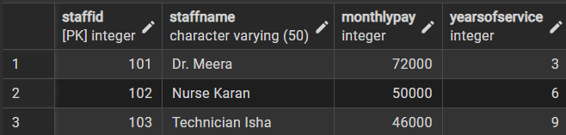

Step 3: Exception and Status Handling
Ensuring the cursor handles empty result sets or termination signals gracefully.
Query:
-- Query 3
DO $$
DECLARE
staff_record RECORD;
staff_cursor CURSOR FOR
SELECT StaffID, StaffName, MonthlyPay FROM Staff;
BEGIN
OPEN staff_cursor;
-- Check if cursor has data
FETCH staff_cursor INTO staff_record;
IF NOT FOUND THEN
RAISE NOTICE 'No records found in Staff table.';
ELSE
LOOP
RAISE NOTICE 'Processing Staff ID: %, Name: %, Monthly Pay: %',
staff_record.StaffID,
staff_record.StaffName,
staff_record.MonthlyPay;
FETCH staff_cursor INTO staff_record;
EXIT WHEN NOT FOUND;
END LOOP;
END IF;
CLOSE staff_cursor;
EXCEPTION
WHEN OTHERS THEN
RAISE NOTICE 'An error occurred: %', SQLERRM;
END $$;
Output:
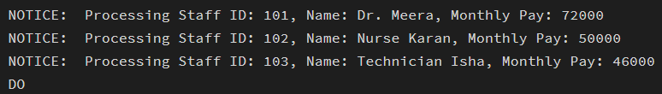

6. Learning Outcomes:
- Understood how to declare, open, fetch, loop through, and close a cursor in PL/pgSQL
- Applied conditional logic inside a cursor to update table records dynamically.
- Implemented basic exception handling to manage runtime errors in procedural SQL blocks.

